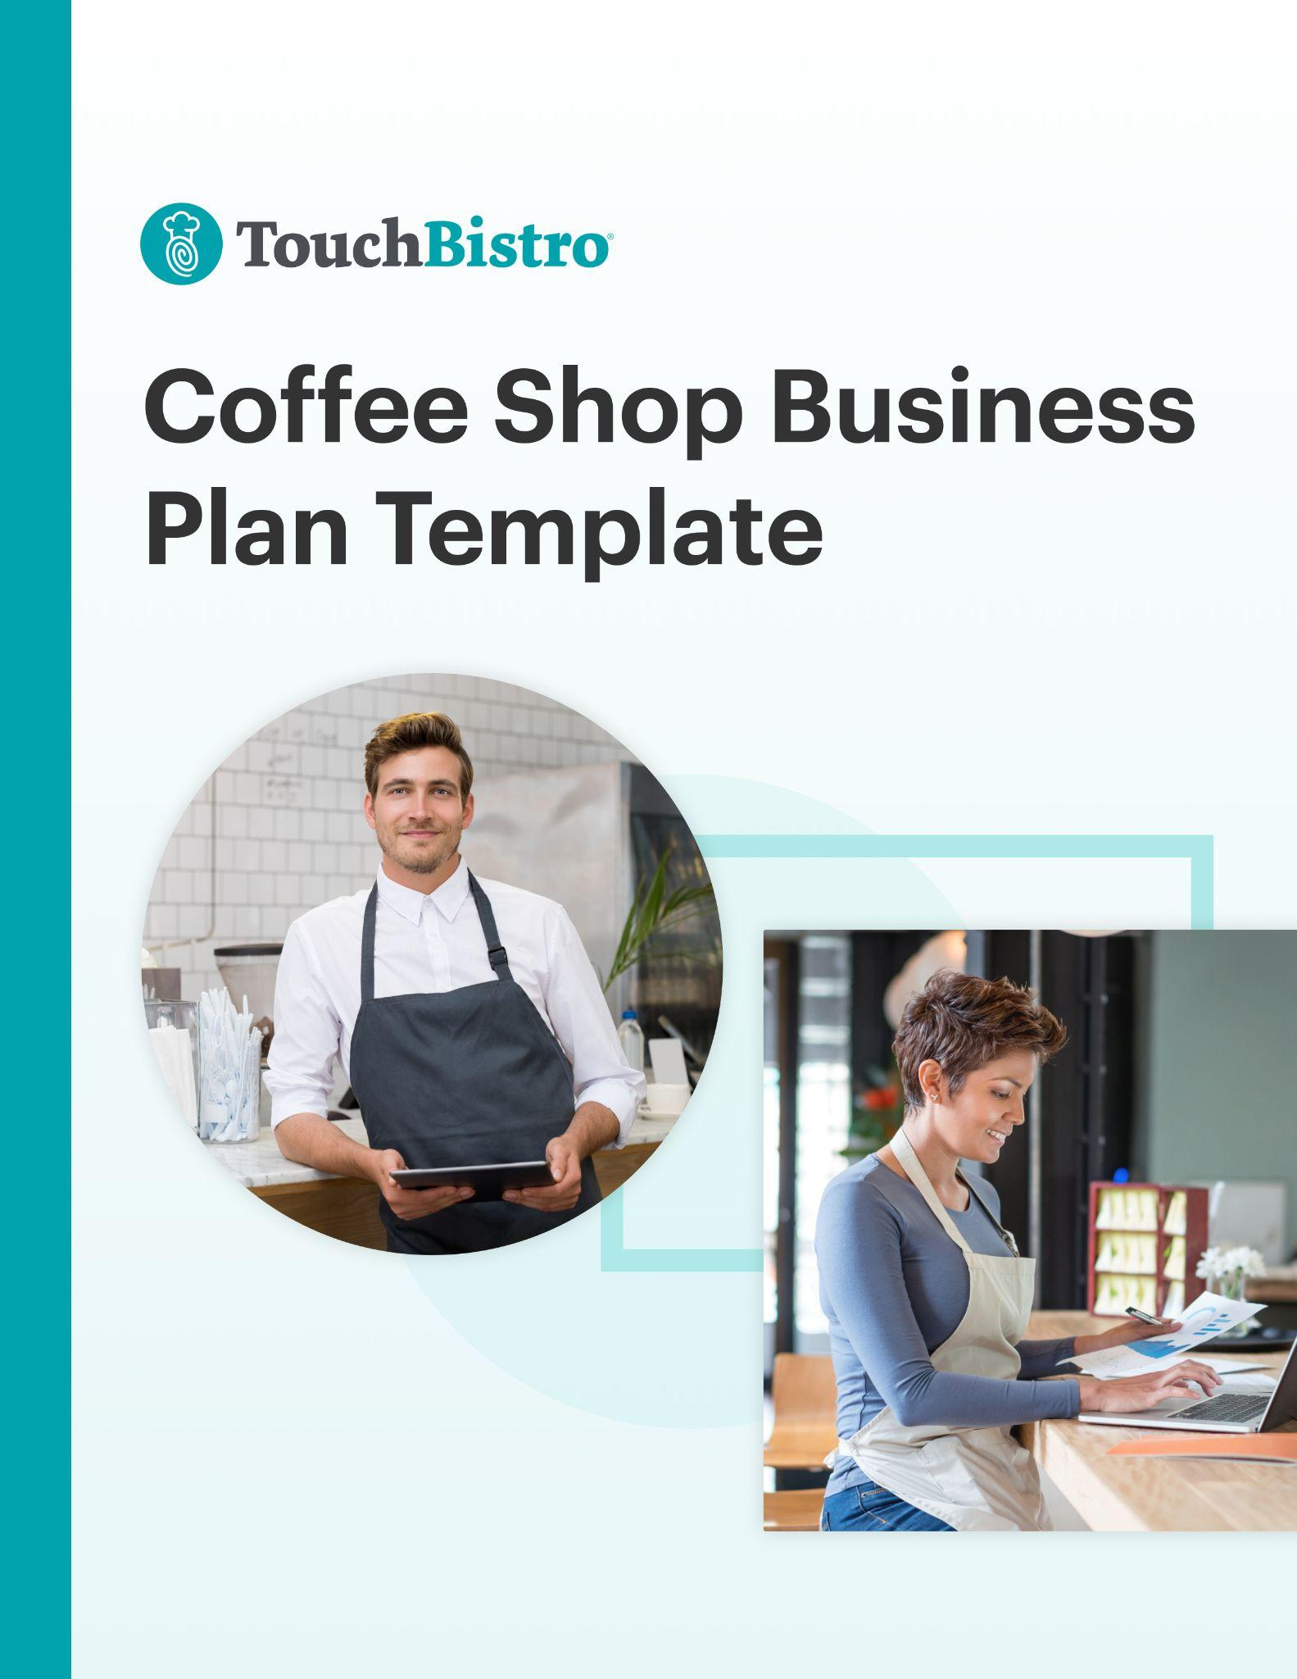


Thank you for downloading TouchBistro’s Coffee Shop Business Plan Template!

This coffee shop business plan template will help you outline the vision for your new business and share that vision with your investors.

Instructions
This coffee shop business plan is designed to be fully customized. Under each header, you’ll notice a description for the section in red italics. To customize each section, simply delete the red text and add your own information.

Once you’ve finished filling in each section, delete any remaining red text, as well as the cover page and this instructional page.

To print your template: Click File > Print
To save the template as a PDF: Click File > Save As > PDF

[YOUR COMPANY LOGO]

Business Plan for [NAME OF COFFEE SHOP]

ADDRESS
PHONE NUMBER
WEBSITE
EMAIL

Table of Contents

Here you’ll find the outline for each section of your coffee shop business plan. You can adjust the table of contents as you customize each subsection of your business plan.

Executive Summary

Business Overview

Management and Staff

Market Analysis

Marketing and Publicity

Operations Plan

Financial Forecast and Expenses

Appendix

Executive Summary

A coffee shop business plan should always start with an executive summary. This section should summarize your main points, while also inviting the reader (often an investor) to read the rest of your business plan.

This section should also highlight key elements that will be discussed throughout the rest of your business plan, such as:

Business Overview
- Your coffee shop’s name, concept, and menu items: For example, “Joe’s is a hip coffee shop that focuses on providing high-quality coffee blends, along with a variety of drinks and teas, cookies, and pastries.”
- Your mission statement and guiding principles.
- Your location and foot traffic: For example, explain if you are in a central location, such as near a college with students, or a building with office professionals. If you have data with the number of potential customers near your coffee shop, you can include that too.
- Your coffee shop model: Discuss how you will serve coffee – whether that’s in a kiosk, drive through, pick up or a sit-down coffee shop. For example, “A small seating area will allow guests to have small social meetings in the coffee shop.”
- Your coffee shop’s ambiance: Describe the atmosphere of your retail store. For example, “a relaxing environment with light jazz background music where guests can enjoy a cup of freshly brewed coffee.”
- Information on the management team: Mention the team’s experience, knowledge of the coffee shop industry, and understanding of how to run the operational side of the business.

Success Factors
- Facility/lease information and your seating capacity: This includes any important information about your retail layout. For example, explain how your patio will contribute to your coffee shop’s success by providing a comfortable place for guests to enjoy the warm weather.
- Your market position and competitive advantage: Think of what makes your business stand out. Maybe you’re the only coffee shop targeting a young student population, for example.
- Management experience: Emphasize the years of experience your management team has working in the coffee industry. For example, “Our General Manager has 20 years of running successful coffee shops.”

Financial Highlights
- Your financial projections and break even point.
- What funds you need and how you plan to use them to achieve success.
- A summary of potential costs and the expected return on investments.

While it may be tempting to try to include a lot of information right off the bat, try to keep this section to 200-600 words max.

Business Overview

This is the section where you fully introduce your new business. The purpose of this section is to provide your reader with a high-level overview of your coffee shop idea and to answer key questions that investors may have, such as the business concept, service model, and ownership structure.

As you fill out each of the sections below, keep in mind that this section can easily come across as a bit dry and mundane. Think about how you can make your business idea stand out with passionate language and captivating details.

Concept
In this section, provide a high-level overview of the concept for your new coffee shop. While you don’t need to go into too many specifics here, you may want to touch on:
- The defining theme for your coffee shop
- The drinks and food you plan to offer
- What price point will you serve

Service Model
It’s important to explain what kind of coffee shop service model you will be using and why. Every coffee shop is different, but here are some of the most popular service models to consider:

- Grab-and-go coffee shop: Pickup or drive-thru only, so your guests can grab a drink and leave quickly
- Traditional coffee shop: Staff sell baked goodies and a variety of coffee drinks, in a relaxed atmosphere
- The coffee bar: Like a homey living room, with lounge music, WiFi, and fresh coffee

Sample Menu
Here you’ll want to include a sample menu for your coffee shop, with separate menus for drinks and food (if applicable). This section should also include your strategy for menu pricing, menu design, and menu engineering. Here are a few tips:

- Write about the type of coffee beans that set you apart. For example, what if you sell organic beans, unlike your competitors? What if you’re the only coffee shop on the block to offer flavored coffee beans?
- Explain why you are serving certain drinks to your target market. For example, tell your reader that you offer frappuccinos, hot chocolates, and cakes topped with icing to cater to a younger customer base with a sweet tooth. Alternatively, let your reader know if your customer base is more health-conscious, and that’s why you have chosen to serve less indulgent items like teas, “light” coffee specialty drinks, and a variety of low-sugar desserts.
- Think about where your food will be eaten – in-venue or off-premise. For instance, if your customers will be hungry, such as students on lunch break, or employees on their way to work, then consider including items like pastries that can be eaten on the go.

Need help designing a sample menu? Start with one of these free menu templates.

Design & Layout
Here you should provide an overview of your coffee shop design and layout. Be sure to touch on how each of these elements complements your brand:

- Your coffee shop concept: Choose an aesthetic that your customers will enjoy. For example, will your shop be modern? Retro? Family-friendly? Healthy? Hip and trendy?
- Storefront signage: What will the outside of your coffee shop look like? Will you have a memorable sign that stands out and reflects your employees, products, and brand identity?
- Coffee shop equipment: How have you designed your coffee shop to fit your equipment? Can you accommodate your premium coffee brewing and blending equipment? What about your coffee shop POS?
- Color scheme: Describe the colors of your coffee shop, your artwork, and wall decor.
- Plateware, flatware, and cutlery: Is there anything special about the tableware you use to serve customers?
- Small decor: What about the finishing touches? Do you have small vases? Candles? Sculptures?
- Staff uniform: Were your staff uniform designed a certain way to reflect your brand image?

When creating a diagram of your design layout, be sure to include any rooms or elements that are key to your business success and that improve your guest experience, such as:

- Ordering counter
- Dining area
- Entrance and exit
- Windows and doors
- Storage spaces
- Tables and chairs (be sure to include how many customers can be seated)
- Break room/employee lounge area
- Food preparation or kitchen area
- Air conditioning and heating vents
- Restrooms

Management and Staff
This section should provide more information about yourself, your staff, and the management team you’ve assembled for your new coffee shop. When talking about yourself, highlight any relevant experience that will aid in your success. When talking about your team, include the names of everyone involved, their backgrounds, and their individual responsibilities.

Here are a few suggestions of what to include:

- For each business owner who will manage your coffee shop, write about their experiences and qualifications that will make them successful.
- Include details of who will take care of your day-to-day coffee shop operations.
- Describe any major roles like cashiers who take care of your sales, baristas who make drinks, your marketing or advertising manager, or your accountant who takes care of your bookkeeping.
- Identify if roles are full-time or part-time, how you will recruit and train new hires, as well as what you will pay in salaries or wages, in addition to benefits or company perks.

Market Analysis

This section is where you describe the specific location of your new coffee shop and the current market conditions. In addition to general information about your target market, you want to explain your unique positioning in the market, the target audience you’re hoping to appeal to, and how you’ll make your coffee shop stand out.

Location
Explain the location of your new coffee shop and why you chose that specific area. If you have not yet chosen a location, describe the town or neighborhood you plan to do business in. For example, mention if your coffee shop is near a major tourist area that is known for its foot traffic. If your coffee shop is near a school or office building, you can mention that too.
If you are one of many coffee shops in a location, consider pointing out what makes you different, such as your wide variety of specialty coffees, or your welcoming atmosphere with spacious tables, comfortable chairs, and lots of natural lighting.

Target Market
Describe your target market and your ideal customer profile. Include key information such as market size, demographics, characteristics, and guest behaviors. If you performed any market research before starting your coffee shop, make sure to include that too. For example, if you have data on a high demand for espresso in your location, the sales potential for a drive-thru espresso pickup or a takeout stand could be very promising.

Market Positioning & Strategy
Here you should describe how you’ll actually reach your target audience. Outline how you’ll position your brand and how you’d like it to be perceived by customers.

Competitive Analysis
In this section, you want to explain the current competitive landscape, as well as your own competitive advantage.

It’s more than likely that there are other coffee shops in your area targeting the same demographics, which means you’ll need to explain how you’ll stand out from the competition. The best way to do this is to include a SWOT analysis for your coffee shop that outlines your business’ strengths and weaknesses, as well as any external opportunities and threats you’d face. This will help investors better understand the specific aspects of your business that will give you a competitive advantage over similar concepts in the area.

Here is a simple example of what your SWOT analysis could look like:
Strengths:
A leadership team with a combined 35+ years of coffee shop experience.
Weaknesses:
The ramp-up time for new staff could set financial projections back.
Opportunities:
Our location is located in a college district, which would provide a steady flow of foot traffic around breakfast and lunchtime.
Threats:
An established coffee shop that serves similar coffee beverages is located in close proximity, which may take away some of our market share.

In your SWOT analysis, remember to not only identify weaknesses and threats, but also how you can overcome them. You want to reassure investors that your business will succeed despite the challenges you’ll face.

Marketing and Publicity

Your marketing plan section details the marketing strategy and tactics you’ll employ to get the word out about your coffee shop. This section should go into detail about how you plan to market your coffee shop, both before and after you open.

You’ll describe how you want to drive incoming traffic, in addition to what budget you have in mind, and your expected return on investment. If you have a lot of detailed information, you may want to create a separate marketing plan document.

New to coffee shop marketing? Download our Ultimate Guide to Restaurant Marketing for some tips you can use.

Promotions Strategy
Your promotions strategy refers to the plan and tactics you will use to increase your coffee shop product or service demand. It can include the following elements:

Public Relations
Whether you plan to hire a PR firm or do it yourself, here is where you should detail the PR strategy for your coffee shop. Include any materials you may send to newspapers and other relevant publications, such as a press release about your coffee shop opening or VIP invites to the soft opening.

Advertising
Here, highlight the different advertising channels you plan to use for your coffee shop. This can include digital advertising channels such as email marketing and paid search, as well as more traditional advertising tactics like flyers and radio ads.

Social Media
These days, nearly every restaurant leverages social media for marketing. Explain how you will use social media to reach your target audience, including which platforms you’ll use (i.e. Facebook, Instagram, etc.), what kind of content you’ll share, and how you’ll build a digital community around your restaurant.

Community Partnerships
No coffee shop operates in a vacuum. Here you should explain any partnerships with influencers or community organizations, in addition to charitable initiatives.

Free Samples
Mention if you will initially give free coffee samples to people visiting your coffee shop for the first time to let them taste the quality of your blends and learn more about what you offer.

Product Strategy
This refers to what beverage and food products you will offer, and how you will stand out from your competitors. For example, will you offer non-coffee drinks, frappuccinos, espressos, or cold brews?

Pricing Strategy
Here, you’ll discuss your average price point and how it compares to competitive coffee shops. For example, will you offer moderate pricing so that customers feel like they’re getting great value when making a purchase at your coffee shop?

Location Strategy

For this section, explain how your location will impact your coffee shop’s success. For example, will you operate kiosks, and if so, where will they be placed to attract more customers?

Operations Plan

In this section, you need to explain how your coffee shop will operate day-to-day once you’re up and running. This section should touch on key aspects of your business operations, including your staffing strategies, the technologies and equipment you plan to use, labor and workflows, and your suppliers.

Staffing & Training
Staffing is a major hurdle for just about every coffee shop. This section should break down your complete staffing strategy, including how you plan to recruit new staff and the hiring criteria for each role. You should also include details about how many people you expect to hire for each role and the approximate pay for each position. For example, will you hire a barista to brew coffee? What about kitchen staff to do food preparation, menu creation, and cleaning?

In addition to hiring, this section should also touch on day-to-day staff management, including how you will handle scheduling, payroll, and labor reporting. If you are hiring a manager to oversee payroll and human resources, be sure to mention this in your Operations Plan.
You may also want to include details about staff training procedures and work safety standards for your coffee shop.

Technology & Equipment
In this section, provide an overview of key technology you’ll use in your coffee shop, inventory management software, online ordering system, and more. You should also mention key pieces of specialized equipment you plan to use.

Here are some examples of what to include in this section:

- Coffee machines like a coffee grinder, a brewing machine, or a hot water dispenser
- Specific arrangements like a sandwich prep table, counterspace, or a display case
- Technology such as a coffee shop POS to process transactions

Kitchen Layout & Workflow
Here, you’ll want to provide an overview of your kitchen functions, such as your food preparation workflow and retail layout of your coffee shop. This can include your floor plan of your coffee brewing area or other visual aids, which you can include here and/or attach them in the appendix.

Remember to include retail functions in your workflow such as:
- Order fulfillment processes (for dine-in and pickup): This covers all of your activities involved
from the moment a barista receives an order until it is handed out to customers.
- Customer service strategies: These are everyday practices for interacting with customers, like welcoming diners when they walk in, using respectful greetings, and listening intently to what the customer wants.
- Cleaning and maintenance practices: This is how you keep the coffee shop clean. For example, by mentioning how you keep the counter organized and clutter-free, and how often you clean your coffee machines/equipment.

Inventory & Suppliers
Related to your coffee back bar layout are the operational processes you adhere to, such as your coffee/food cost control methods, and inventory suppliers. Provide an overview of the type of vendors you’ll use and how you’ll manage inventory as well as food/drink costs. If applicable, include the cost of using various food and drink vendors.

To help you figure out what vendors and suppliers you use, first think of the inventory items in your coffee shop. After all, each inventory item had to be sourced from someone or somewhere:

- Products: You may have products like different types of coffee beans to use for your freshly brewed joe, a variety of teas, bottled water or juices, and ingredients for baked goods, salads, or sandwiches. In addition, you might sell other items like souvenir mugs, thermos containers, or bags of whole-bean coffee.
- Equipment: To successfully run your coffee shop, you’ll need to source a variety of equipment that should last for several years to come. For example, this may include an espresso machine, coffee grinders, and ice machines. If you plan to put bags of whole-bean coffee on display, then you will need shelving or display cases. Additional equipment may include microwaves or toaster ovens for preparing bagels or sandwiches. You will also need a coffee shop POS as well as a cash register to keep track of sales and inventory.
- Additional supplies: Think of your supplies required to serve coffee to customers, such as paper cups and takeaway containers for carrying multiple drinks. In addition, you might need to source clear plastic cups for cold drinks, lids, napkins, stirrers, straws, or even large containers for group orders.

Financial Forecast and Expenses

Though your financial analysis is one of the last sections of your business plan, it’s also one of the most important sections. In fact, many investors may skip straight to this section to see a breakdown of your anticipated costs and projected revenue, as well as how you plan to spend their investment.

Since coffee shops are often smaller retail storefronts, often with a lower profit margin, this section needs to emphasize how your business will grow and be profitable in the long-term.

Before finalizing this section, triple-check your projections and consider hiring a financial professional to make sure your numbers are sound.

Startup Costs
In this section, you’ll need to disclose how much money you’ll need to get your business off the ground, including your biggest expenses.

Financing & Loans
Most coffee shop owners or managers require loans or other sources of funding to get up and running. In this section, detail the types of financing or loans you require to fuel your growth.

Investment Plan
Here, explain the initial investment you are hoping to receive and how you plan to spend it during your first year in business.

Sales Forecast
Your sales forecast should highlight your projected weekly, monthly, and/or annual first-year sales projections. To get this number, you may use different criteria, such as capacity limits, table turn rates, delivery and/or takeout options, menu prices, and more.

Projected Profit & Loss Statement
Use a projected (or pro forma) P&L statement to show how much money you expect to have made (or lost) by the end of your first year in business. This figure should be based on your sales forecast, as well as your projected coffee shop costs.

Break-Even Analysis
A break-even calculation reveals the amount of revenue needed in order for your coffee shop to make a profit. You can then compare this number to your sales forecast to determine how long it will take for you to break even so you can let your investors know when they can expect to start seeing an ROI. This takes into account your fixed costs, like payroll, rent, utilities and coffee/food supplies.

Expected Cash Flow
Cash flow is the amount of cash that’s coming in, and going out of your business. For a coffee shop, this figure will vary based on how often you expect to purchase inventory, the size of your staff, your payroll schedule, and various other factors. In this section, you want to detail your expected cash inflows and outflows for an upcoming period (usually a year).

This section includes projected cash flow statements for all of your kitchen equipment, machinery, labor and supplies. Consider costs for maintaining your coffee shop, paying employee wages, coffee making equipment, coffee beans and teas, as well as pastries or sandwiches. Since investors want to know you can handle cash, try to be thorough with monthly projections to prove that you will be able to avoid credit risk.

Appendix
Last but not least is your appendix. While this section is optional, it’s a great place to include charts, plans, graphics, pictures, or any other material investors may find useful. In your appendix, you may want to include:
- A sample menu
- Floor plans for your coffee shop including the seating area for guests, espresso bar, and break room for employees.
- Additional financial charts and figures
- Design mockups for your logo or other branding

